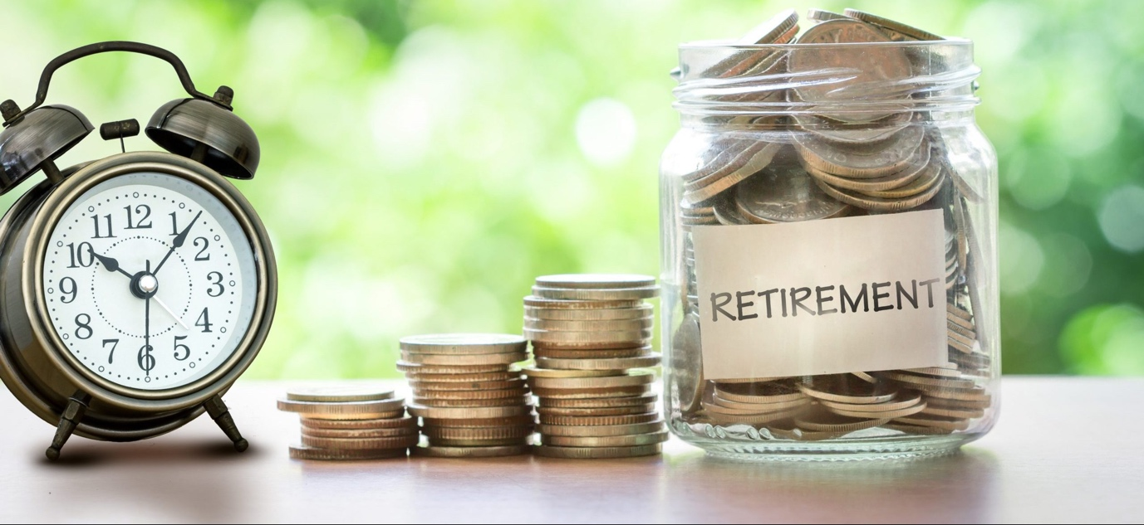

Swiss Old Age pension

The Australian CSA delegates are often approached with practical questions related to the Swiss Old Age pension. The article summarises three main topics.

Reaching retirement age – What to do?
The Swiss old age pension isn’t paid automatically when you reach statutory retirement age. The Central Compensation Office (CCO) in Switzerland recommends submitting your pension claim no later than three months prior to reaching the statutory retirement age, as this will give the compensation office sufficient time to gather the information needed to calculate your pension. The applicable form can be downloaded from the website of the CCO:
https://tinyurl.com/mh88ftk5

Annual Life Certificate – Why?
The Swiss Compensation Office (CCO) used to send yearly a life and civil status certificate to all Old Age pension recipients. This was to check that beneficiaries are still alive.

This has changed in 2022. From this year, Swiss nationals residing abroad who are registered with the Swiss embassy or consulate of their country of residence will no longer be asked to provide a life certificate, as this information will be transmitted directly from the Register of the Swiss Abroad to the Central Compensation office. The change will be staggered throughout 2022 and each beneficiary will be informed when they no longer need to submit the certificate life certificate.

Swiss Old Age Pension recipients who are not registered with the Swiss representation will continue to be asked to submit a life certificate.
More information: https://tinyurl.com/48bx7eby

Tax deduction from ATO – How to claim?
Once you are receiving an income from the Swiss Social Insurance (AHV/AVS or IV/AI) you may be entitled to claim a deduction, to reduce the amount of tax you pay in Australia.

The deduction applies to your personal contributions towards your Swiss Social Insurance in Switzerland (including voluntary contributions made while residing outside of Switzerland). In order to allow the ATO to determine your eligibility, you will need to request a statement from the Swiss Compensation Office, which certifies the total amount of your personal contribution paid into the Swiss Social Insurance. Follow the steps below to lodge your claim:

Steps:
- Request a statement from the CCO in Geneva relating to your personal contributions into the Swiss Social Insurance. Click on https://bit.ly/2yQshEl for the Swiss request form.

The Swiss Compensation Office will check the request and send you a statement via mail that contains your personal contribution figure.

- Submit the statement from Switzerland to the ATO along with a request to determine the deductible amount. Click on https://bit.ly/2VLTVeK for the Australian request form.
The ATO will advise you on the amount you may claim as deduction in a private ruling.

Further links
Website Central Compensation Office, Geneva, Switzerland
Website Consulate General of Switzerland, Sydney, Australia

Please note that this article provides general information and should not be regarded as legal or tax advice. Separate advice relating to your individual circumstances should be obtained from a professional.

By Carmen Trochsler, CSA Delegate Adelaide / Beat Knoblauch, CSA Delegate Sydney, updated Sep 2022 | Contact: info@csa-oceania.org

